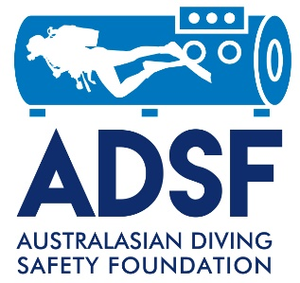

AED Safety Promotion Grant Application

Name of Dive Operation _____________________________________________________
Address ___________________________________________________________________________
Contacts:
Business owner:
Name: _________________________________________________________
Tel: _______________________ Email: ______________________________

AED Safety Promotion Grant Questionnaire

- How long has the business existed? _______ years
- What is the average age group of your clients? _______ years
- How many clients do you normally have in a year? ______
- What is the type and size of your boat(s)? ___________________________________________________________________
___________________________________________________________________
- How long would it likely take emergency services to reach your vessel at your usual dive locations? _______ minutes/hours
- Do you carry oxygen equipment on your vessel? ______ If so, please describe the equipment available and also provide a photograph
__________________________________________________________________________________________________________________________________________
- What level of first aid training does/do your dive supervisor(s) have? _____________________________________________________________________
_____________________________________________________________________
Please provide a copy of their current first aid/CPR certification
- If you receive an ADSF AED grant, do you agree to participate in our annual survey of AED usage? _______

I confirm that the information provided above is correct.
Name of Dive Operation __________________________________________________________
Name of Authorised Officer _______________________________
Signature of Authorised Officer ____________________________
Signature of witness_________________________________
Name of witness _________________________________
Date ______________________

