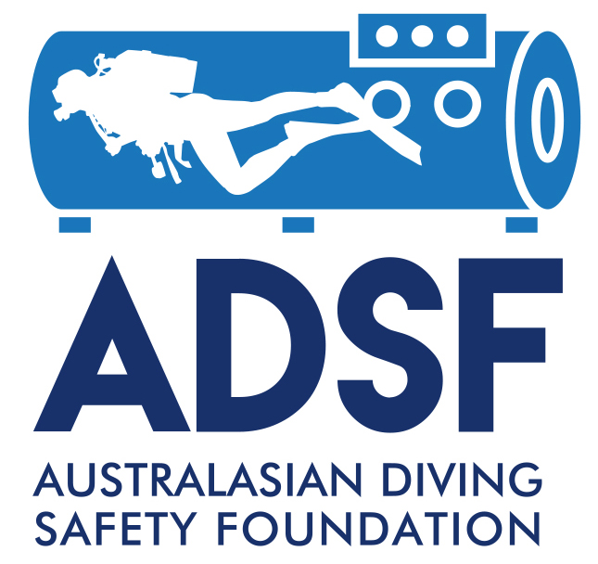

The Australasian Diving Safety Foundation
Diving Medical Training Scholarship (General)

Application Form

Formatting Guidelines
Font | Arial 12 point.
Line spacing | Single.

SUBMISSION INSTRUCTIONS

Applicants are responsible for ensuring that all relevant information has been included in their application.

Application forms must be emailed as PDF files and named using the following convention: SURNAME_2019_Nameofdocument (e.g. SMITH_2019_Application_DiveMedicalTrainingScolarship.

Applications must be emailed to johnl@adsf.org.au.

INCOMPLETE APPLICATIONS WILL NOT BE ACCEPTED.

1. PERSONAL INFORMATION

Surname:

First Name:

Title:

Academic & Medical Qualifications:

Diving qualifications (if any)

Residential address:

Organisation:

Location:

Position:

Telephone:

Email:

2. DIVING MEDICAL COURSE

Please provide details of the diving medical course that you wish to attend. Include name and location of program, and the organisation conducting it.

3. POTENTIAL BENEFITS TO THE DIVING COMMUNITY

Please provide details of how you believe your attendance at the course could help to reduce diving-related morbidity and mortality, particularly for Australian divers.

