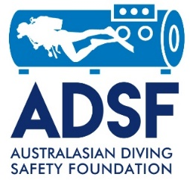
Oxygen Unit Safety Promotion Grant Application (Operator)
- How long has the business existed? _______ years
- How many clients do you normally have in a year? ______
- How long would it likely take emergency services to reach your usual dive locations? _______ minutes/hours
- Do you already have oxygen equipment? Yes / No
If so, please describe the equipment available
__________________________________________________________________________________________________________________________________________
- Do your dive supervisors have oxygen first aid qualifications? Yes / No
Please provide a copy of their current oxygen first aid certification
- What Oxygen Unit would you purchase if you received a grant?
_____________________________________________________________________
I confirm that the information provided above is correct.
Name of Dive Operation __________________________________________________________
Name of Authorised Officer _______________________________
Position of Authorised Officer _______________________________
Signature of Authorised Officer ____________________________
Signature of witness_________________________________ Name of witness _________________________________
Date ______________________
- Grants awarded to applicant at the sole discretion of the ADSF. You will be notified if your application was successful. Successful applications will need to produce evidence of purchase prior to the grant being paid.

