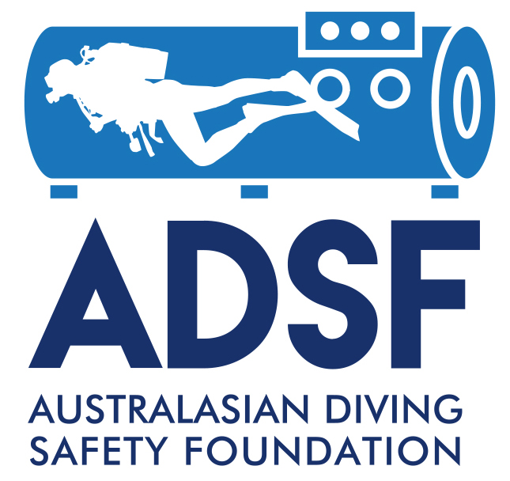

The Australasian Diving Safety Foundation
Diving Safety Promotion Grant Scheme

Application Form

Formatting Guidelines
Font | Arial 12 point.
Line spacing | Single.

SUBMISSION INSTRUCTIONS

Applicants are responsible for ensuring that all relevant information has been included in their application.

Application forms must be emailed as PDF files and named using the following convention: SURNAME_2018_Nameofdocument (e.g. SMITH_2018_Application_SafetyGrant).

Applications must be emailed to johnl@adsf.org.au.

INCOMPLETE APPLICATIONS WILL NOT BE ACCEPTED.

1. GENERAL INFORMATION

Type of application (tick box)

Dive operator

Dive club

Individual

Other (details)

Project Title
20 words maximum

Has this project / activity, or a similar or related project / activity, received funding elsewhere or currently under review by another funding body?

Yes No

If yes, provide the name of the funding body and details of what has been / will be received.

Proposed duration of the project

Start date: | End date:

Details of main organiser

Surname:

First Name:

Organisation:

Location:

Position in Institution:

Country

Qualifications / Background:

Telephone:

Email:

2. PROJECT DETAILS

2.1. Project description and potential outcomes (max. 300 words)
Summarise the aims, significance and expected outcomes of the project.

2.2. Relevance to the aims of the Dive Safety Promotion Grant Scheme (max. 100 words)
Briefly explain how the project meet the aims of the Grant Scheme.

2.3. Feasibility environment (max. 100 words)
Briefly explain the feasibility of the project and describe the environment (facilities, infrastructure and funding) available to support the proposed project.

2.4. Information on the project (max. 3 pages)
Provide a detailed plan using the titles:
- Background and significance of the promotion
- Aims and objectives
- Project design
- Methods (e.g. how the aims will be achieved and measured)
- Timeline
- Expected outcomes

3. BUDGET AND JUSTIFICATION

Summarise and justify your budget in the table below -add more space as necessary.

Personnel Support |  |  |  | Totals
Direct Activity Costs
Other Costs
TOTAL

Budget justification (max 500 words)

