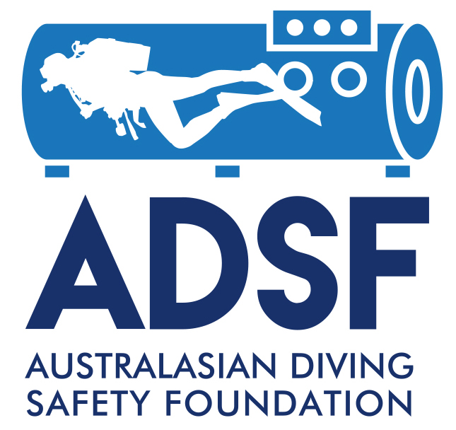

The Australasian Diving Safety Foundation
Carl Edmonds Memorial Diving Medicine Scholarship

This scholarship, for AUD$4,500, is only available for civilian applicants to the Royal Australian Navy Medical Officers’ Underwater Medicine Course.
Priority will be given to self-funded Australian and NZ Nationals.

Application Form

Formatting Guidelines
Font | Arial 12 point.
Line spacing | Single.

SUBMISSION INSTRUCTIONS

Applicants are responsible for ensuring that all relevant information has been included in their application.

Application forms must be emailed as PDF files and named using the following convention: SURNAME_2019_Nameofdocument (e.g. SMITH_2019_Application_DiveMedicalTrainingScolarship.

Applications must be emailed to johnl@adsf.org.au.

INCOMPLETE APPLICATIONS WILL NOT BE ACCEPTED.

1. PERSONAL INFORMATION

Surname:

First Name:

Title:

Telephone:

Email:

Academic & Medical Qualifications:

Diving qualifications (if any):

Nationality:

Residential address:

Employer:

Location:

Position:

Telephone:

Email:

Referees:

1.

2.

2. POTENTIAL BENEFITS TO THE DIVING COMMUNITY

Please provide details why you are applying for the scholarship and of how you believe your attendance at the course could help to reduce diving-related morbidity and mortality, particularly for Australian divers.

Important note:

One Scholarship is available for each course and only to civilian applicants accepted into the course by the Royal Australian Navy.

